Ysgol y Grango
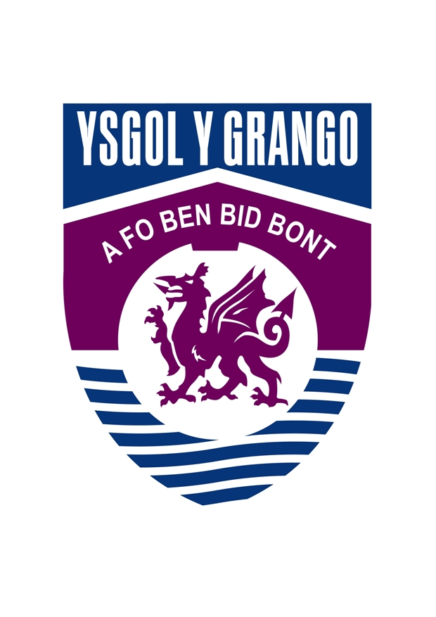
Numeracy
Booklet
Contents
Topic | Page
Calculating Methods – Add, Subtract, Multiply and divide | 3
Types of Numbers – Even, Odd, Square Numbers,  Triangular Numbers, Factors, Prime Numbers | 5
Place Value | 7
Fractions, Decimals, Percentages | 8
Ratios | 10
Directed Numbers | 11
Co-ordinates | 14
Inequalities | 15
Shapes | 16
Perimeter and Area | 19
Volume | 22
Metric and Imperial Units | 23
Temperature | 24
Time | 25
Bearings | 27
Discrete Data – Pictogram, Bar Chart, Line Graph, Pie  Chart | 28
Continuous Data – Line Graph, Conversion Graph,  Scatter Diagram | 31
Averages – Mean, Median, Mode, Range | 32
Vocabulary | 33
Calculating methods
Addition
Example 534 + 2678
Place the digits in the correct “place value” columns with the numbers under each other. Begin adding in the units column.
Show any carrying in the next column
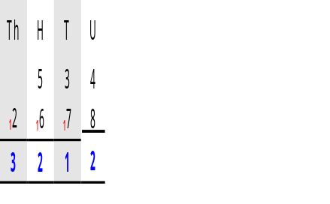
+

Subtraction

Example: 7686 - 749
Place the digits in the correct “place value” columns with the numbers under each other. Begin subtracting in the units column.

You can’t subtract 9 from 6 so ‘borrow from next door’, move 1 from the 8, to change the 6 into 16.

Note that the same has happened with the hundreds.

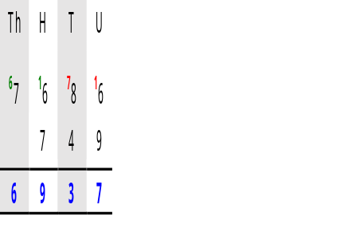
-

Multiplication – Grid Method
You need to split the numbers into hundreds, tens and units, and multiply them together.
Example: 253 x 94
x | 200 | 50 | 3
90 | 18 000 |  | 270
4

200 x 90 = 18 000 3 x 90 = 270
Multiply each number on the top with the numbers on the side:
x | 200 | 50 | 3
90 | 18 000 | 4 500 | 270
4 | 800 | 200 | 12
Then, add all the numbers inside the grid together:
18 000
4 500
270
800
200
12
253 x 94 = 23 782

23 782
1 1
Division

Example: 432 ÷ 8
It is written:
It isn’t possible to divide 4 by 8, therefore the 4 is carried to the next column.
43 ÷ 8 = 5, with remainder 3. Carry the 3 to the next column. Write 5 on the top line. 32 ÷ 8 = 4. Write 4 on the top line.
432 ÷ 8 = 54

Types of numbers

Even numbers Square numbers

2, 4, 6, 8, 10, 12, ………… 12 = 1 x 1 = 1
2 divides exactly into every even number. 22 = 2 x 2 = 4
32 = 3 x 3 = 9
Odd numbers 42 = 4 X 4 = 16
52 = 5 X 5 = 25
1, 3, 5, 7, 11, ………… 62 = 6 x 6 = 36
2 doesn’t divide exactly into odd numbers. 72 = 7 x 7 = 49

The first 10 square numbers are:
1, 4, 9, 16, 25, 36, 49, 64, 81, 100
Triangular numbers Factors
1 = 1 A factor is a number that
1 + 2 = 3 divides exactly into another
1 + 2 + 3 = 6 number.
1 + 2 + 3 + 4 = 10 The factors of 12 are:
1 + 2 + 3 + 4 + 5 = 15 1, 2, 3 ,4, 6, 12
1 + 2 + 3 + 4 + 5 + 6 = 21
1 + 2 + 3 + 4 + 5 + 6 + 7 = 28 The factors of 13 are 1 and 13

The first seven triangular numbers are:
1, 3, 6, 10, 15, 21, 28

Prime numbers
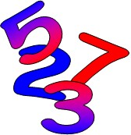
A prime number has exactly two
factors, namely 1 and itself.

The factors of 17 are 1 and 17, therefore 17 is a prime number.

The prime numbers between 1 and 100 are:

2, 3, 5, 7, 11, 13, 17, 19, 23,
29, 31, 37, 41, 43, 47, 53, 59, 61,
67, 71, 73, 79, 83, 89, 97

Note: 1 is not a prime number since it only has 1 factor.
Place value

Thousands  (1000) | Hundreds  (100) | Tens  (10) | Units  (1) | . | Tenths  1  10 | Hundredths  1  100 | Thousandths  1  1000

10 units | = | 1 ten | 10 thousandths | = | 1 hundredth
10 tens | = | 1 hundred | 10 hundredths | = | 1 tenth
10 hundreds | = | 1 thousand | 10 tenths | = | 1 unit

The placement of the digits within the number gives us the value of that digit.

The digit 4 has the value of |  | The digit 5 has the value
4 thousand |  | of 5 tenths ( 5/10 )
(4000)
4 2 8 | 4 . 5 6 7

The digit 8 has the value The digit 7 has the value
8 tens (80) 7 thousandths ( 7/1000 )
Fractions

The numerator is the number
on the top of the fraction
3

4

The denominator is the number on the bottom

If we have a number and a fraction mixed we call it a 7
3
mixed fraction. 8

When the numerator is larger than the denominator we 9
call this an improper fraction.
7

Equivalent fractions

All the fractions below represent the same proportion. Therefore they are called equivalent fractions.

1/2 2/4 4/8

1 2 3 4 5
= = = =

= . . . .

2 4 6 8 10

1 2 3
= = =
3 6 9

1 2 3
= = =
4 8 12
4 5
=
12 15

4 5
=
16 20

= . . . . etc.
= . . . .

3 6 9
= =
12 15
= =

= . . . .


4 8 12 16 20

Decimals

A decimal is any number that contains a decimal point. The following are examples of decimals.
0⋅549 1⋅25 256⋅4 3⋅406

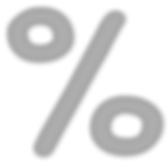
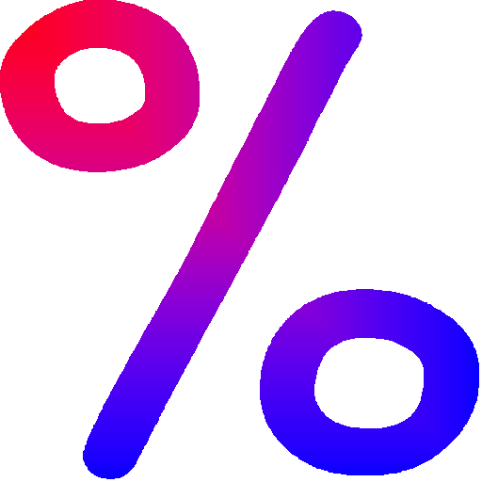
Percentages

 |  | The symbol % means | 1
 |  | The symbol % means | 100

7% | means | 7/100
63% | means | 63/100
100% means 100/100 or 1 whole.
120% means 120/100 It is possible to have a percentage that is greater than 1 whole.
Changing decimals and fractions into percentages
To change a decimal or fraction to a percentage you have to multiply with 100%.

0⋅75 x 100% = 75%

13 x 5100% = 65% or 13 x 100% = 1300 = 130 = 65%
120 20 20 2

To change a fraction into a decimal you have to divide the numerator with the
denominator.
3 = 3 ÷ 8 = 0⋅375
8

It is also possible to change a fraction into a percentage like this:

2 = 2 ÷ 3 = 0⋅6666 . . . = 0⋅67 (to 2 decimal places )
3

then 0⋅67 x 100% = 67%

Therefore 2 = 67% (to the nearest one part of a hundred)
3
Useful fractions, decimals and percentages

Fraction Decimal Percentage

1 |  | 1⋅0 | 100%
1/2 |  | 0⋅5 | 50%
1/3 |  | 0⋅33..... | 33%
1/4 |  | 0⋅25 | 25%
3/4 |  | 0⋅75 | 75%
1/10 |  | 0⋅1 | 10%
2/10 | ( = 1/5 ) | 0⋅2 | 20%
3/10 |  | 0⋅3 | 30%
Ratio

Ratio is used to make a comparison between two things.

Example

☺☺ ☺☺ ☺☺ ☹☹ ☺☺ ☺☺ ☺☺ ☹☹ ☺☺ ☺☺ ☺☺ ☹☹

In this pattern we can see that there are 3 happy faces to every sad face.
We use the symbol : to represent to in the above statement, therefore we write the ratio like this:

Happy : | Sad | Sad : | Happy
3 : | 1 | 1 : | 3

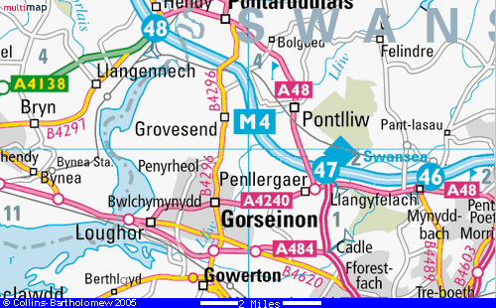

Ratio is used in a number of situations:

• In a cooking recipe
• In building when mixing concrete
• It is used in the scale of maps
e.g. if a scale of 1 : 100 000 is used,
it means that 1 cm on the map represents
100 000 cm in reality which is 1 km.

Numeracy Bo
Directed numbers

The negative sign ( - ) tells us the number is below zero e.g. -4. The number line is useful when working with negative numbers. Below is a part of the number line.

Negative direction ← → Positive direction
-9 | -8 | -7 | -6 | -5 | -4 | -3 | -2 | -1 | 0 | 1 | 2 | 3 | 4 | 5 | 6

The numbers on the right are greater than the numbers on the left e.g. 5 is greater
than 2 and 2 is greater than -3. Note that -3 is greater than -8.

The Number line game can be used to add and subtract negative numbers:

Rules:
Start at zero facing the positive direction. The symbol + means “step forward”.
The – sign means “step backwards” .
When you see a number, step that number of places. Your position at the end will be the answer.


Example: – 3 – 4 + 6

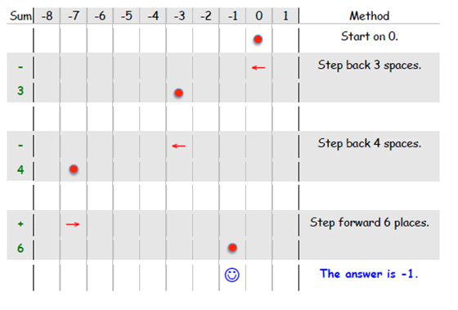

Example: 2 + – 8 – – 9

• • • •

-9 | -8 | -7 | -6 | -5 | -4 | -3 | -2 | -1 | 0 | 1 | 2 | 3 | 4 | 5 | 6
☺☺

• Start at 0.
• Step forward 2 spaces.
• Step backwards 8 spaces.
• Step forward 9 spaces. The answer is 3

Add and Subtract Negative Numbers
Adding a negative number is the same as subtracting:
3 + -4 = 3 – 4 = -1

Subtracting a negative number is the same as add:
3 - -4 = 3 + 4 = 7

Multiplying and dividing directed numbers

We multiply and divide directed numbers in the usual way whilst remembering these very important rules:
÷ | + | -
+ | + | -
- | - | +

Two signs the same, a positive answer. Two different signs, a negative answer.

× | + | -
+ | + | -
- | - | +

Remember, if there is no sign before the number, it is positive.

Examples:

5 | x | -7 | = | -35 | (different signs gives a negative answer)
-4 | x | -8 | = | 32 | (two signs the same gives a positive answer)
48 | ÷ | -6 | = | -8 | (different signs gives a negative answer)
-120 | ÷ | -10 | = | 12 | (two signs the same gives a positive answer)

Co-ordinates

We use co-ordinates to describe location.

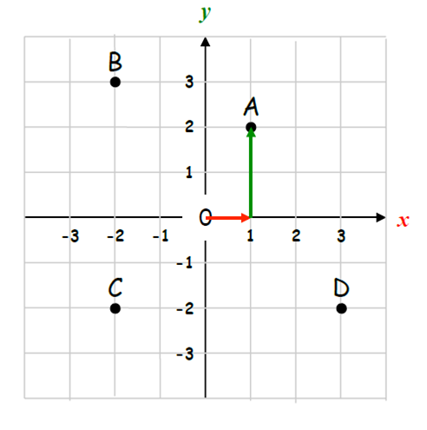

The co-ordinates of the points are:

A(1,2) B(-2,3) C(-2,-2) D(3,-2)

There is a special name for the point (0,0) which is the origin.

The first number (x-coordinate) represents the distance across from the origin. The second number (y-coordinate) represents the distance going up or down.

Example: The point (1,2) is one across and two up from the origin.

Example: The point (-4,-3) is four across to the right and three down from the origin.

Inequalities

We use the = sign to show that two sums are equal. If one sum is greater than or less than the other we use inequalities:

< less than > more than

< less than or equal to > more than or equal to

Examples :

5 < 8 43 > 6

5 is less than 8 43 is greater than 6

x < 8 y > 17

x is less than or equal to 8 yis greater than or equal to 17

Names of two dimensional shapes

A polygon is a closed shape made up of straight lines. A regular polygon has equal sides and equal angles.

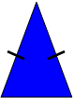
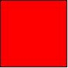
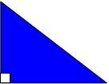

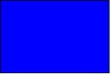
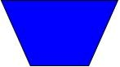
Equilateral triangle Right angled triangle Isosceles triangle

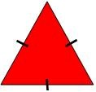
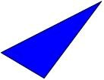
Scalene triangle Square Rectangle

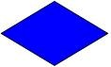
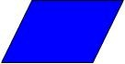
Parallelogram Rhombus Trapezium

Opposite sides parallel and equal.
Opposite sides parallel, all sides equal.
One pair of opposite sides parallel.

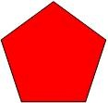
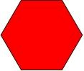
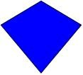
Kite Pentagon Hexagon

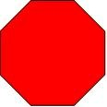
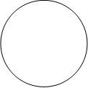
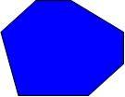

Heptagon Octagon Circle

3D shapes

3D means three dimensions – 3D shapes have length, width and height.

Shape | Name | Faces | Edges | Vertices  (corners)
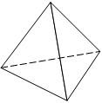 | Tetrahedron | 4 | 6 | 4
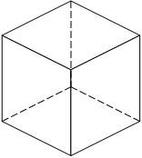 | Cube | 6 | 12 | 8
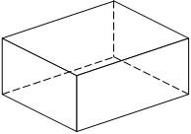 | Cuboid | 6 | 12 | 8
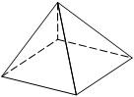 | Square based pyramid | 5 | 8 | 5
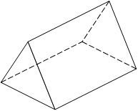 | Triangular prism | 5 | 9 | 6




The circle

Circumference

Radius

Diameter

Centre

Chord

Tangent

Circumference of a circle

The circumference of a circle is the distance around the circle.

Circumference = 2 π x radius
Circumference = 2 π r

Since the diameter is twice the length of the radius, we can also write

Circumference = π x diameter
Circumference = π d
π (pi)
π is a Greek letter which represents
3•1415926535897932384 . . . . . (a decimal that carries on forever without repetition)
We round π to 3•14 in order to make calculations or we use the π button on the calculator.

Perimeter and Area

Perimeter

Perimeter is the distance around the outside of a shape. We measure the perimeter in millimetres (mm), centimetres (cm), metres (m), etc.

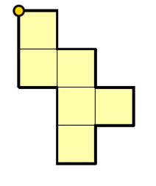
This shape has been drawn on a 1cm grid. Starting on the orange circle and moving in a clockwise direction, the distance travelled is . . .


1 + 1 + 1 + 1 + 1 + 1 + 1 + 1 + 1 + 2 + 1 + 2 = 14cm

Perimeter = 14cm

Area of 2D Shapes

The area of a shape is how much surface it covers. We measure area in square units e.g. centimetres squared (cm2) or metres squared (m2).

Areas of irregular shapes

Given an irregular shape, we estimate its area through drawing a grid and counting the squares that cover the shape.

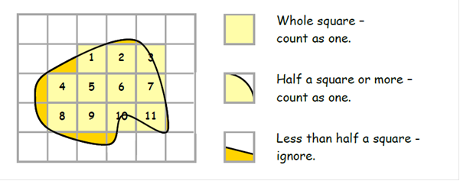

Area = 11cm².


Remember that this is an estimate and not the exact area.

Area

Rectangle Triangle

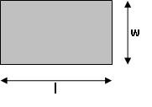
Multiply the length with the width. Multiply the base with the height and divide by two.
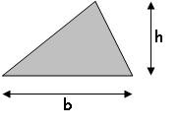
^{b x h}
Area = l x w Area =
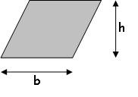
₂

Trapezium Parallelogram
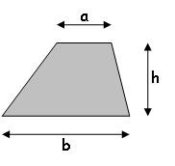

Add the parallel sides, multiply with the
height and divide by two.

Area = (a + b) h

₂
Multiply the base with the height.

Area = b x h

Circle

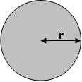

Multiply the radius with itself, then multiply with π.

Area = r x r x π = πr²

Volume

Volume is the amount of space that an object contains or takes up. The object can be a solid, liquid or gas.

Volume is measured in cubic units e.g. cubic centimetres (cm3) and cubic metres (m3).

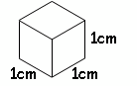

Cuboid

Note that a cuboid has six rectangular faces.

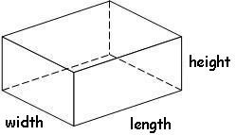 Volume of a cuboid = length x width x height

Prism

A prism is a 3-dimensional object that has the same shape throughout its length i.e. it has a uniform cross-section.

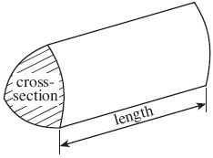 Volume of a prism = area of cross-section x length

Metric units of length

Imperial units of length 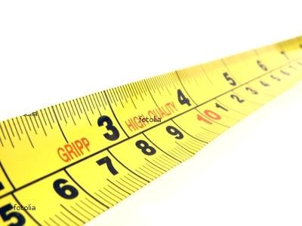
Millimetre | mm | 10 mm = 1 cm 1 000 mm = 1 m
Centimetre | cm | 100 cm = 1 m 100 000 cm = 1 km
Metre | m | 1 000 m = 1 km
Kilometre | km

Inch | in or “ | 12 in = 1 ft
Foot | Ft or ‘ | 3 ft = 1 yd
Yard | yd | 1 760 yd = 1 mile
Mile | mi

Metric units of mass
Milligram mg 1 000 mg = 1 g 1 000 000 mg = 1 kg
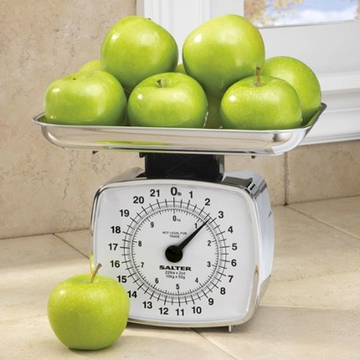
Gram g 1 000 g = 1 kg Kilogram kg 1 000 kg = 1 t Metric tonne t

Imperial units of mass
Ounce oz 16 oz = 1 lb Pound lb 14 lb = 1 st Stone st 160 st = 1 t

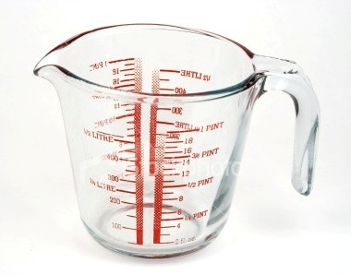
Metric units of volume
Millilitre ml 1 000 ml = 1 l
Litre l

Imperial units of volume
Pint pt 8 pt = 1 gal
Gallon gal

Converting between imperial and metric units

Length
1 inch ≈ 2.5 cm
1 foot ≈ 30 cm
1 mile ≈ 1.6 km
5 miles ≈ 8 km

Weight/Mass
1 pound ~ 454 g
2.2 pounds ~ 1 kg
1 ton ~ 1 metric tonne

Volume
1 gallon ≈ 4.5 litre
1 pint ≈ 0.6 litre(568 ml)
1¾ pints ≈ 1 litre

Temperature

Converting from Celsius (°C) to Fahrenheit (°F)

Use the following formula

F = 1.8 x C + 32

Converting from Fahrenheit (°F) to Celsius (°C)

Use the following formula

C = (F – 32) ÷ 1.8

The freezing point of water is 0°C or 32°F

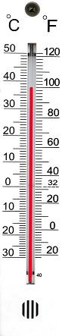

N
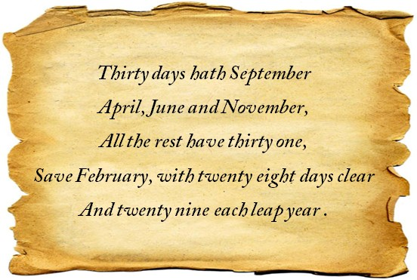
Time

1000 | years | = | 1 millennium
100 | years | = | 1 century
10 | years | = | 1 decade
60 | seconds | = | 1 minute
60 | minutes | = | 1 hour
24 | hours | = | 1 day
7 | days | = | 1 week
12 | months | = | 1 year
52 | weeks | ≈ | 1 year
365 | days | ≈ | 1 year
366 | days | ≈ | 1 leap year

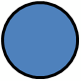
The Yearly Cycle

Season | Month  January | Days  31
 | February | 28
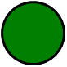 | March | 31
 | April | 30
 | May | 31
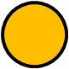 | June | 30
 | July | 31
 | August | 31
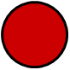 | September | 30
 | October | 31
 | November | 30
 | December | 31

The 24 hour and 12 hour clock

 | 24 hour |  |  | 12 hour
Midnight | 00:00 |  |  | 12.00 a.m. | Midnight
The 24 hour clock always uses 4 digits to show the time.  The 24 hour system does not use a.m. nor p.m. | 01:00 |  |  | 1:00 a.m. | The 12 hour clock shows the time with a.m. before mid- day and p.m. after mid-day.
 | 02:00 |  |  | 2:00 a.m.
 | 03:00 |  |  | 3:00 a.m.
 | 04:00 |  |  | 4.00 a.m.
 | 05:00 |  |  | 5:00 a.m.
 | 06:00 |  |  | 6:00 a.m.
 | 07:00 |  |  | 7:00 a.m.
 | 08:00 |  |  | 8:00 a.m.
 | 09:00 |  |  | 9:00 a.m.
 | 10:00 |  |  | 10:00 a.m.
 | 11:00 |  |  | 11:00 a.m.
Mid-day | 12:00 |  |  | 12:00 p.m. | Mid-day
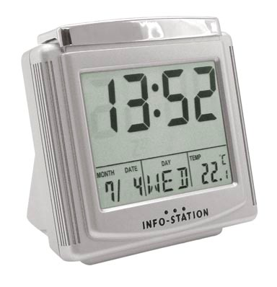 | 13:00 |  |  | 1:00 p.m. | 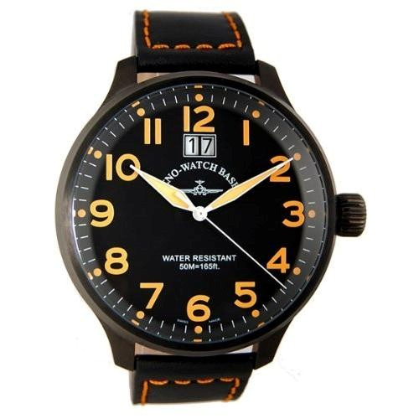
 | 14:00 |  |  | 2:00 p.m.
 | 15:00 |  |  | 3:00 p.m.
 | 16:00 |  |  | 4:00 p.m.
 | 17:00 |  |  | 5:00 p.m.
 | 18:00 |  |  | 6:00 p.m.
 | 19:00 |  |  | 7:00 p.m.
 | 20:00 |  |  | 8:00 p.m.
 | 21:00 |  |  | 9.00 p.m.
 | 22:00 |  |  | 10.00 p.m.
 | 23:00 |  |  | 11:00 p.m.

Time vocabulary

02:10 | Ten past two in the morning | 2:10 a.m.
07:15 | Quarter past seven in the morning | 7:15 a.m.
15:20 | Twenty past three in the afternoon | 3:20 p.m.
21:30 | Half past nine in the evening | 9:30 p.m.
14:40 | Twenty to three in the afternoon | 2:40 p.m.
21:45 | Quarter to ten at night | 9:45 p.m.

Bearings

A bearing describes direction. A compass is used to find and follow a bearing. The diagram below shows the main compass points and their bearings.

315°
W

N
000°

N

045°

E
E

270° W
090°

SW
225°

S
180°
SE
135°










N – North, S – South, E – East, W - West

The bearing is an angle measured clockwise from the North.

Bearings are always written using three figures e.g. if the angle from the North is 5°, we write 005°.

Data

There are two types of data:

Discrete data  Things that are not measured: | Continuous data  Things that are measured:
• Colours  • Days of the week  • Favourite drink  • Number of boys in a family  • Shoe size | • Pupil height  • Volume of a bottle  • Mass of a chocolate bar  • Time to complete a test  • Area of a television screen

Discrete data

Collecting and recording

We can record data in a list

e.g. here are the numbers of pets owned by pupils in form 9C:

1 , 2 , 1 , 1 , 2 , 3 , 2 , 1 , 2 , 1 , 1 , 2 , 4 , 2 , 1 , 5 , 2 , 3 , 1 , 1 , 4 , 10 , 3 , 2 , 5 , 1

A frequency table is more structured and helps with processing the information.

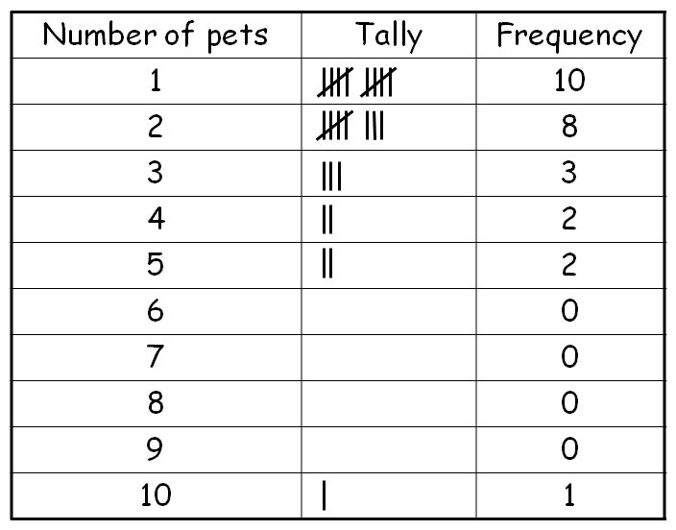

Displaying
In order to communicate information, we use statistical diagrams. Here are some examples:

Pictogram
A pictogram uses symbols to represent frequency. We include a key to show the value of
each symbol.

The diagram below shows the number of pets owned by pupils in 9C.

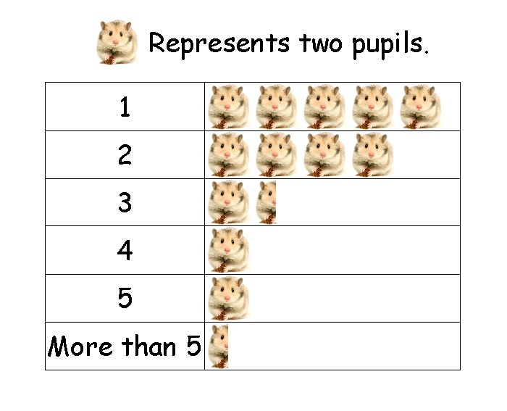

Bar chart
The height of each bar represents the frequency. All bars must be the same width and have a constant space between them. Notice that the scale of the frequency is constant and starts from 0 every time. Remember to label the axes and give the chart a sensible title.
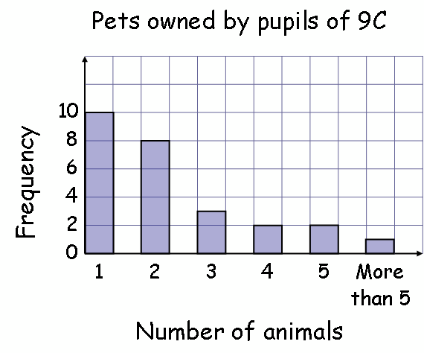

Vertical line graph
A vertical line graph is very similar to a bar chart except that each category has a line instead of a bar. Notice that the category labels are directly below each line.

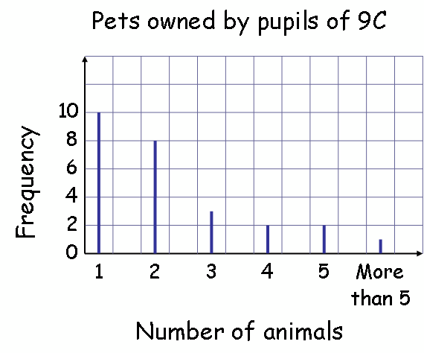

Pie chart
The complete circle represents the total frequency. The angles for each sector are calculated as follows:

Here is the data for the types of pets owned by 9C
Divide 360° by the total of the frequency:
360° ÷ 36 = 10°
Therefore 10° represents one animal

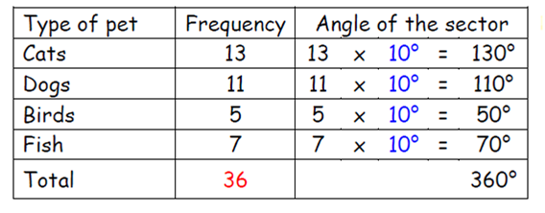

Remember to check that the angles of the sectors add up to 360°.
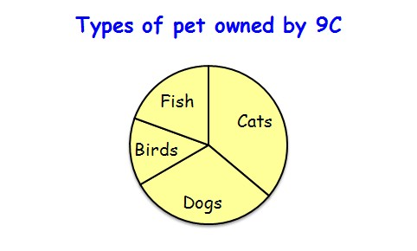

Displaying
Continuous data

With graphs representing continuous data, we can draw lines to show the relationship between two variables. Here are some examples:

Line graph
The temperature of water was measured every minute as it was heated and left to cool.
A cross shows the temperature of the water at a specific time. Through connecting the crosses with a curve we see the relationship between temperature and time.

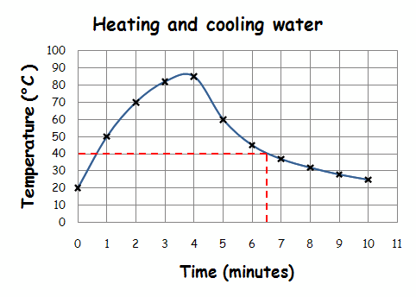
The line enables us to estimate the temperature of the water at times other than those plotted e.g. at 6½ minutes the temperature was approximately 40 °C.

Conversion graph
We use a conversion graph for two variables which have a linear relationship. We draw it in the same way as the above graph but the points are connected with a straight line.

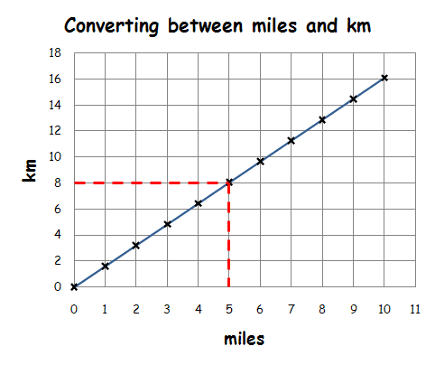
From the graph, we see that 8 km is approximately 5 miles.

Scatter diagram
We plot points on the scatter diagram in the same way as for the line graph. We do not join the points but look for a correlation between the two sets of data.

Positive correlation No correlation Negative correlation

If there is a correlation, we can draw a line of best fit on the diagram and use it to estimate the value of one variable given the other.

The following scatter graph shows a positive correlation between the weights and heights of 12 pupils.

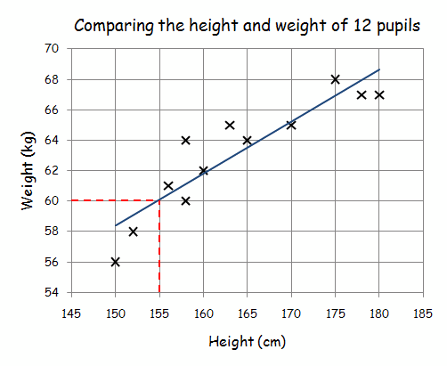
The line of best fit estimates the relationship between the two variables. Notice that the line follows the trend of the points.
There are approximately the same number of points above and below the line. We estimate that a pupil 155 cm tall has a weight of 60 kg.
Important things to remember when drawing graphs

• Title and label axes

• Sensible scales

• Careful and neat drawing with a pencil

Average

The average is a measure of the middle of a set of data. We use the following types of average:

Mean - We add the values in a set of data, and then divide by the number of values in the set.

Median - Place the data in order starting with the smallest then find the number in the middle. This is the median. If you have two middle numbers then find the number that’s halfway between the two.

Mode - This is the value that appears most often.
Spread

The spread is a measure of how close together are the items of data. We use the following to measure spread:

Range -
The range of a set of data is the difference between
the highest and the lowest value.

Example

Find the mean, median, mode, and range of the following numbers:

4 , 3 , 2 , 0 , 1 , 3 , 1 , 1 , 4 , 5

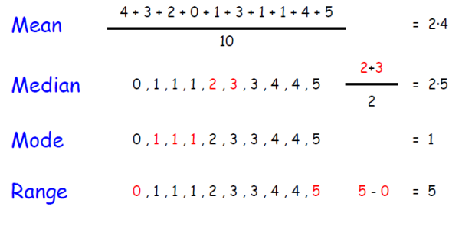

Vocabulary / Geirfa

Acceleration Cyflymiad
Acute angle | Ongl lem
Add Adio
Angle | Ongl
Anti-clockwise Gwrthglocwedd
Approximation Brasamcan
Area Arwynebedd
Average Cyfartaledd
Axis | Echelin

Balance | Cydbwysedd
Bearing | Cyfeiriant
Bills | Biliau
Bisect/Halve | Haneru
Boundary | Ffin

Calculator | Cyfrifiannell
Capacity | Cynhwysedd
Cash | Arian Parod
Circle | Cylch
Circumference | Cylchyn
Clockwise | Clocwedd
Column | Colofn
Compass (drawing circles) | Cwmpas (llunio cylchoedd)
Compass (points North) | Cwmpawd (pwyntio i’r Gogledd)
Cone | Côn
Co-ordinates | Cyfesurynnau
Corresponding | Cyfatebol
Cross-section | Trawsdoriad
Cube | Ciwb
Curve | Cromlin
Cylinder | Silindr
Cheapest | Rhataf

Decimal | Degolyn
Density | Dwysedd
Deposit | Blaendal
Depth | Dyfnder
Diagonal | Croeslin
Diameter | Diamedr
Dice | Dîs
Digit | Digid
Dimension | Dimensiwn
Discount | Disgownt
Drawn to scale | Lluniadu wrth raddfa

East | Dwyrain
Edge | Ymyl
Enlarge | Helaethu
Equal/Unequal | Hafal/Anhafal
Equivalent | Cywerth
Estimate | Amcangyfrif
Even number | Eilrif
Extend | Ymestyn

Factor | Ffactor
Fraction | Ffracsiwn
Frequency | Amlder

Gradient (slope) | Graddiant

Height | Uchder
Horizontal | Llorweddol

Index | Indecs
Interest (rate) | Llog (cyfradd llog)
Intersection | Croesdoriad
Interval | Cyfwng
Invest | Buddsoddi
Irregular | Afreolaidd

Layer/Tier | Haen
Length | Hyd
Loan | Benthyciad
Loss | Colled
Lower/Reduce | Gostwng

Mass | Màs
Maximum | Uchafswm
Mean | Cymedr
Measure | Mesur
Median | Canolrif
Minimum | Lleiafswm
Mode | Modd
Multiple | Lluosrif

Net | Rhwyd
North | Gogledd

Obtuse angle | Ongl aflem
Octagon | Octagon
Odd number | Odrif

Parallel | Paralel
Percent | Canran
Perimeter | Perimedr
Perpendicular | Perpendicwlar
Power | Pwer
Pressure | Gwasgedd
Prime number | Rhif cysefin
Probability | Tebygolrwydd
Profit | Elw

Quadrilateral | Pedrochr

Radius | Radiws
Range | Amrediad
Rate of exchange | Cyfradd cyfnewid
Ratio | Cymhareb
Rectangle | Petryal
Reduce/Decrease | Lleihau
Reflection | Adlewyrchiad
Reflex angle | Ongl atblyg
Remainder | Gweddill
Right angle | Ongl sgwâr
Round off | Talgrynnu
Row | Rhes

Salary (income) | Cyflog (incwm)
Save | Cynilo
Scale | Graddfa
Solution | Datrysiad
South | De
Space | Gofod
Speed | Buanedd
Sphere | Sffêr
Square | Sgwâr
Square number | Rhif sgwâr
Square Root | Ail Isradd
Substitute | Amnewid
Symmetry | Cymesuredd

Total | Cyfanswm
Triangle | Triongl
Triangular number | Rhif triongl

Unknown | Anhysbysyn
Unlikely | Anhebygol

Value Added Tax (VAT) | Treth ar Werth (TAW)
Velocity | Cyflymder
Vertex | Fertig
Vertical | Fertigol
Volume | Cyfaint

Weight | Pwysau
West | Gorllewin
Width | Lled

